CAMBRIDGE GROUP PLC

Mexico Mining Project
Complete Information Pack
Hermenegildo Galeana / Gold Mine 12 • Baja California, Mexico

Compiled from the project documents supplied for the CamBridge transaction review

1. Executive Summary
This document consolidates the material supplied regarding the proposed mining transaction in Baja California, Mexico. It brings together the project overview, proposed transaction structure, mining concessions, historical mineral information, maps, signed partnership agreement, CamBridge transaction draft and the 12‑month development roadmap.
Item | Information in supplied material
Project / working name | Gold Mine 12 / Hermenegildo Galeana mining opportunity
Location | Hermenegildo Galeana / Ensenada area, Baja California, Mexico
Broader property area in CamBridge draft | Approximately 127,681.89576 hectares
CamBridge draft concessions | 12 mining concessions listed
Minerals referenced | Gold, silver, copper, barite, silica sand; regional material also shows lead, antimony, tungsten and bismuth
Historical gold indications | Rio 7 g/t Au; sand 10 g/t Au; rock 4–10 g/t Au
Proposed CamBridge structure | Developer 70%; landowners protected 30% in the CamBridge master-rights draft
Master-rights concept | Exclusive 50-year master lease/development right, subject to transaction trigger in the draft
Initial capital target in roadmap | US$200,000–US$1,000,000
Public-market objective | Prepare for a public listing after professional geological, technical, legal and valuation work
Source note: Figures above are summaries of the supplied documents and are not presented here as independently verified reserves, resources, title opinions or valuations.

Key decision point
The supplied material supports a case for structured due diligence and transaction evaluation, but it also contains material items that require independent verification before a merger, acquisition, valuation or financing decision. In particular, concession status, title/ownership, the relationship between the six concessions in the signed partnership agreement and the twelve concessions in the CamBridge draft, and the geological basis of the historical grade claims should be reconciled.

2. Project and Location
The project material describes a mineral and tourism development opportunity in Baja California, Mexico. The Hermenegildo Galeana presentation states that the parties are co-owners/authorized by partners associated with approximately 127,000 hectares and are open to investment proposals for the Baja California peninsula.
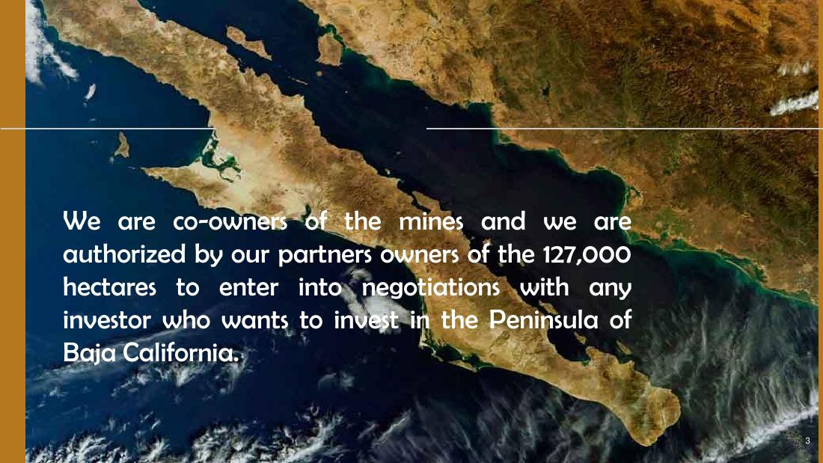
The CamBridge master-rights draft describes the property as approximately 127,681.89576 hectares in Hermenegildo Galeana, Ensenada, Baja California, including twelve mining concessions and associated mineral, development, access and infrastructure rights.
The older promotional presentation also states that the land on the peninsula has approximately 65 kilometres of beach and presents ecotourism as a possible additional land-use opportunity. This is project-promotional information and should be independently confirmed.

3. Mineral and Geological Information
The supplied documents reference a polymetallic setting. The CamBridge draft specifically acknowledges gold, silver, barite and silica sand and refers to historical exploration by Paloma Research & Development. Separate mining-lot records identify Au, Ag and Cu on several lots.
Mineral / element | How it appears in supplied material
Gold (Au) | Historical grade claims and multiple concession records
Silver (Ag) | Multiple concession records and project material
Copper (Cu) | Concession records and regional mineral maps
Barite | Referenced in CamBridge master-rights draft
Silica sand | Referenced in CamBridge master-rights draft
Lead (Pb) | Regional Ensenada mineral map
Antimony (Sb) | Regional Ensenada mineral map
Tungsten (W) | Regional Ensenada mineral map
Bismuth (Bi) | Regional Ensenada mineral map

Historical gold indications
Material / area | Reported indication
Rio | 7 g/t Au
Sand | 10 g/t Au
Rock | 4–10 g/t Au
These numbers are reproduced from the supplied Hermenegildo Galeana presentation. They should be treated as historical/project-owner claims unless and until supported by chain-of-custody sampling, laboratory certificates, QA/QC, geological modelling and an independent technical report prepared to an applicable reporting standard.
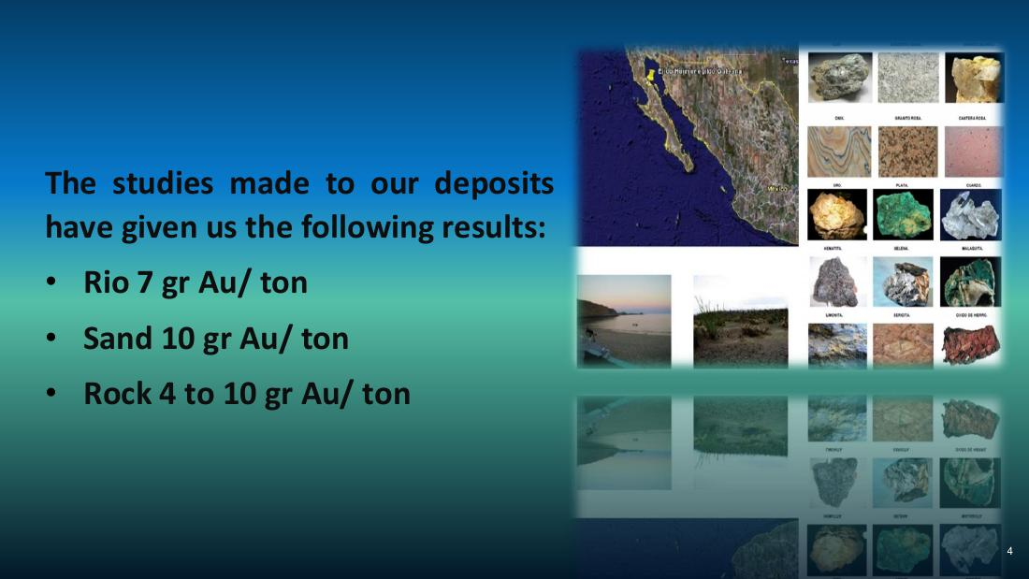

4. Twelve Concessions Listed in the CamBridge Draft
Concession | Area stated in draft
San Francisco | 91 ha
San Francisco 2 | 9 ha
Encanto | 1,052.54 ha
La Magdalena | 1,452.66 ha
La Jojoba de Oro | 445.89 ha
Delicias | 115 ha
La Resolana | 20 ha
4 Amigos 7 | 50 ha
4 Amigos | 200 ha
4 Amigos 2 | 100 ha
4 Amigos 3 | 331.3 ha
4 Amigos 6 | 20 ha
The twelve concessions above are the concessions listed in the CamBridge master mineral rights lease/development draft. The supplied materials do not, by themselves, establish that each of these twelve titles is currently valid, transferable, in good standing, or controlled by the same legal parties. Current Mexican registry verification is therefore a core due-diligence item.

5. Mining-Lot Location and Status Records
A separate six-page location/status document contains records for Rosy, La Limonera, Luz de Mexico, Luz de Mexico Fracción I, Luz de Mexico Fracción II and Chapalita. The statuses shown in that document are mixed.
Lot | Title | Area shown | Minerals shown | Status shown | Holder shown
Rosy | 231062 | 6,755.7969 | Au, Ag, CUA, TSP | CANCELADO | Rolando Parra Rodriguez
La Limonera | 233565 | 22,446.62 | Au, Ag | CANCELADO | Samuel Gallo Martinez y Socios
Luz de Mexico | 217191 | 77 | Au, Ag, Cu | VIGENTE | Javier Eligio Tirado y Socios
Luz de Mexico Fracción I | 232737 | 23,206.3626 | Au, Ag, Cu, CUA | CANCELADO | Martin Refugio Espinoza Lopez y Socios
Luz de Mexico Fracción II | 232738 | 18.8046 | Au, Ag, Cu, CUA | VIGENTE | Martin Refugio Espinoza Lopez y Socios
Chapalita | 232095 | 30,999.7834 | Au, Ag, Cu | CANCELADO | Samuel Gallo Martinez y Socios
This status document is one of the most important due-diligence items in the pack. It should not be assumed that a historic or mapped concession remains valid today merely because it appears in project materials. The current legal status of every relevant concession should be obtained directly from the competent Mexican authorities and reconciled to the transaction documents.
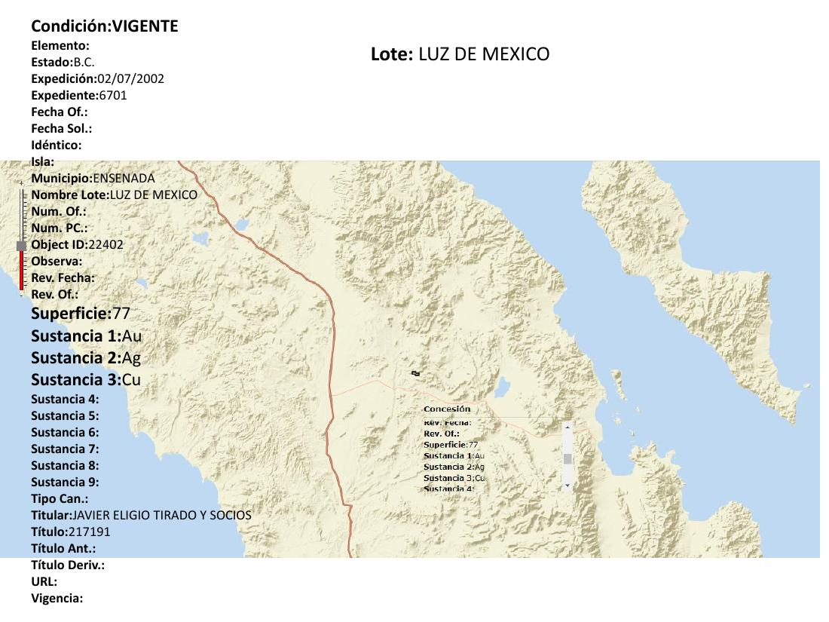

6. Signed Partnership / Joint Venture Agreement
The supplied data room contains a bilingual Spanish/English 'Contrato de Asociación en Participación' / Partnership Agreement. The agreement identifies Rolando Parra Gomez as Partner A and Birgur ehf / Björgvin Þ. Þorsteinsson as Partner B.

Concessions identified in that agreement
Title number | Mine / lot
190752 | La Resolana
231062 | Rosy
232095 | Chapalita
232737 | Luz de México Fracción I
232738 | Luz de México Fracción II
233565 | La Limonera

Commercial structure in the signed agreement
- Partner A contributes/transmits exploitation rights over the identified mines for the purpose of extracting, exploiting and commercialising minerals, subject to the contract terms.
- Partner B may present the opportunity to international investors/advisers/strategic partners and pursue financing and capital-market processes.
- Partner B is to bear the expenses and costs generated by the activities contemplated by the agreement, according to its terms.
- For mineral extraction/sale, the agreement provides for a 70% share of profits to Partner B and 30% to Partner A.
- The agreement states that profit distribution occurs after extraction/commercialisation and includes an illustrative gold-price band of US$4,000–US$5,000 per ounce in the contract text.
- Partner B is responsible for administration of the association and is required to provide monthly written reports covering customers, purchase orders, principal business activities and other agreed matters.
- The agreement allocates association operating expenses to Partner B and places employment-related responsibility for personnel working for the association on Partner B.
- No new associate may be admitted without written consent of the other associate.
- The agreement contains confidentiality provisions.
- The contract states an initial five-year term, with potentially feasible mining rights/activities described as continuing for 20 years where applicable.
- Partner B is granted a right of first refusal/preference if Partner A receives a proposal to sell the real property where the mining lot is located, at a maximum price stated in the contract of US$80,000,000.
- The agreement references Mexican law and courts in Mexicali, Baja California for interpretation/compliance.

Execution / audit-trail point
The Dropbox Sign audit pages supplied with the agreement show signing/viewing activity, but the audit-trail status visible in the supplied PDF also states 'Pending signature' / 'This document has not been fully executed by all signers.' This should be resolved before relying on the document as a fully executed agreement. The visible signature page contains signatures for the principal parties and witnesses, but the electronic audit status should be reconciled with the final executed original.

7. Proposed CamBridge Transaction Structure
A separate draft titled 'Master Mineral Rights Lease, Development and PLC Transaction Agreement' is structured specifically around a potential transaction with CamBridge Group PLC.
Term | Draft position
Parties | Björgvin Þ. Þorsteinsson as Developer; Sociedad de Ejidatarios del Ejido Hermenegildo Galeana represented by Sergio Armando Tapia Huerta and Enrique Reza Armenta as Landowners
Property | Approx. 127,681.89576 hectares plus twelve concessions and associated rights
Master rights | Exclusive 50-year master lease and development right
CamBridge exclusivity | Three months to negotiate with CamBridge Group PLC
Automatic extension | If an LOI, MOU, Term Sheet, Heads of Terms or Definitive Agreement is secured, exclusivity continues until completion/termination
Economic/control structure | Developer controls 70% of transaction/development rights; landowners retain protected 30% equity participation in SPV/transaction structure
Assignment | Developer may assign/transfer/contribute rights to CamBridge, subsidiary, affiliate or transaction SPV
Operating lease | Landowners agree to enter into an operating lease for up to 20 years upon a CamBridge transaction
Costs | Due diligence, legal, geological, accounting, financing, regulatory and listing costs allocated to CamBridge or affiliates in the draft
Anti-circumvention | 36 months
Right of first refusal | Developer has first right to match a competing proposal concerning the property
Confidentiality | Five years
Governing law in draft | England and Wales; courts of England and Wales
Important: this is a draft transaction document. It should not be described as an executed CamBridge agreement unless and until signed by the relevant parties.
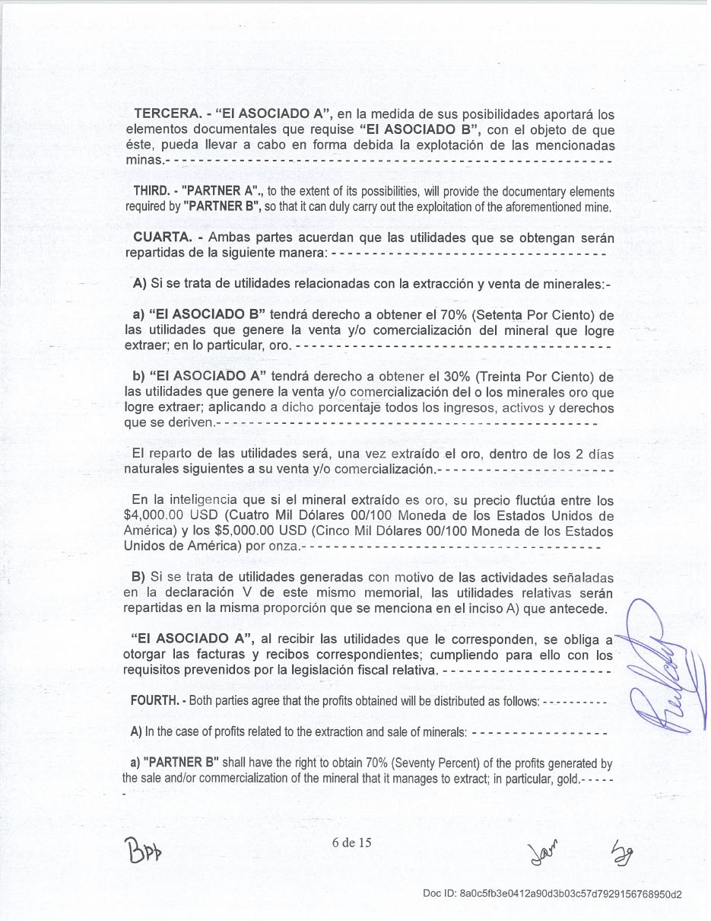

8. 12-Month Roadmap
Phase | Timing | Objective / output
1 | Week 1 | Sign landowner agreement; confirm mining rights/concession ownership; collect geological and concession documents
2 | Weeks 2–12 | Negotiate with CamBridge Group PLC and target signed LOI / Heads of Terms
3 | Months 3–4 | Build professional team: geologists, mining engineers, lawyers, bankers, auditors and valuation specialists
4 | Months 3–6 | Raise initial US$200,000–US$1,000,000 for geological, legal, technical, DD, regulatory and listing preparation
5 | Months 4–8 | Geological/technical programme: review, modelling, sampling, possible drilling, environmental review and mining strategy
6 | Months 6–9 | Independent valuation, market analysis, growth projections and IPO strategy
7 | Months 8–10 | Corporate structuring, SPV, ownership, governance and board
8 | Months 10–12 | Public-market preparation; roadmap names AIM or the London Stock Exchange Main Market as options
The roadmap is aspirational and sequencing-oriented. It does not establish that listing eligibility, technical reporting requirements, funding, regulatory approvals or admission criteria have already been satisfied.

9. Critical Due-Diligence Workstreams
Workstream | What should be verified
Title and concession status | Current registry status, holder, title number, expiry, payments, encumbrances, cancellation/reinstatement history and transferability for every concession relied upon
Land / Ejido rights | Authority of signatories, ejido approvals, land-use rights, surface access and relationship between mineral rights and surface/ejido rights
Scope reconciliation | Why the signed partnership agreement identifies six concessions while the CamBridge draft lists twelve different/partly different concessions
Geology | Original reports, maps, sample locations, laboratory certificates, QA/QC, chain of custody, drilling records and independent competent-person review
Resource classification | Whether any compliant mineral resource/reserve exists under a recognised reporting code; none is established by the supplied pack alone
Environmental / permitting | Environmental authorisations, water, access, exploration/exploitation permits, community and land-use requirements
Corporate authority | Capacity of each party to grant, assign or contribute the rights described
Contract execution | Final signed originals, notarial/registration requirements, and resolution of Dropbox Sign 'pending signature' status
Economics | Independent project economics, capex, opex, recoveries, metallurgy, infrastructure, logistics, taxes and royalties
CamBridge transaction | Board approvals, legal/regulatory analysis, consideration structure, dilution, listing implications and funding responsibility

10. Key Inconsistencies / Open Questions
- The CamBridge draft refers to twelve concessions, while the signed partnership agreement identifies six concessions with different names/title numbers.
- The mining-lot status document marks four of the six displayed lots as CANCELADO and two as VIGENTE. Current official status must be checked.
- The CamBridge draft uses a 70/30 developer/landowner structure, while the signed partnership agreement uses a 70/30 Partner B/Partner A profit split. These are not necessarily the same legal/economic arrangement.
- The signed partnership agreement is governed through Mexican legal provisions/courts in Mexicali, while the CamBridge master-rights draft selects England and Wales. Conflict-of-law and enforceability analysis is needed.
- Historical gold-grade statements are not equivalent to a compliant mineral resource or reserve.
- The project presentation's 127,000-hectare statement and the CamBridge draft's 127,681.89576-hectare property description should be tied to cadastral/land documentation.
- The electronic signing audit trail should be reconciled because the supplied PDF shows a pending/incomplete signature status.

11. Source Document Inventory
Document | Purpose in this pack
Cambridge_PLC_Mining_Agreement_Draft | Proposed 50-year master-rights / CamBridge transaction framework and twelve-concession schedule
Gold Mine 12 Roadmap | 12-month execution, funding, technical and listing roadmap
Hermenegildo Galeana Overview | Project presentation, land-scale statements, historical grade claims, mineral/tourism narrative
Mining Lots Location and Status | Six lot records, title numbers, holders, areas, minerals and displayed status
Ensenada Mineral Maps | Regional maps for copper, silver, lead, antimony, tungsten and bismuth
Signed Partnership Agreement | Bilingual joint-venture/association agreement, six concession titles, 70/30 profit structure and contractual terms
Project Overview | Project summary included in the supplied data-room package
This compilation is a management/due-diligence summary of the supplied source material. It is not a legal opinion, geological report, valuation, title certificate, mineral-resource statement or investment recommendation.

Appendix A – Selected Project Visuals
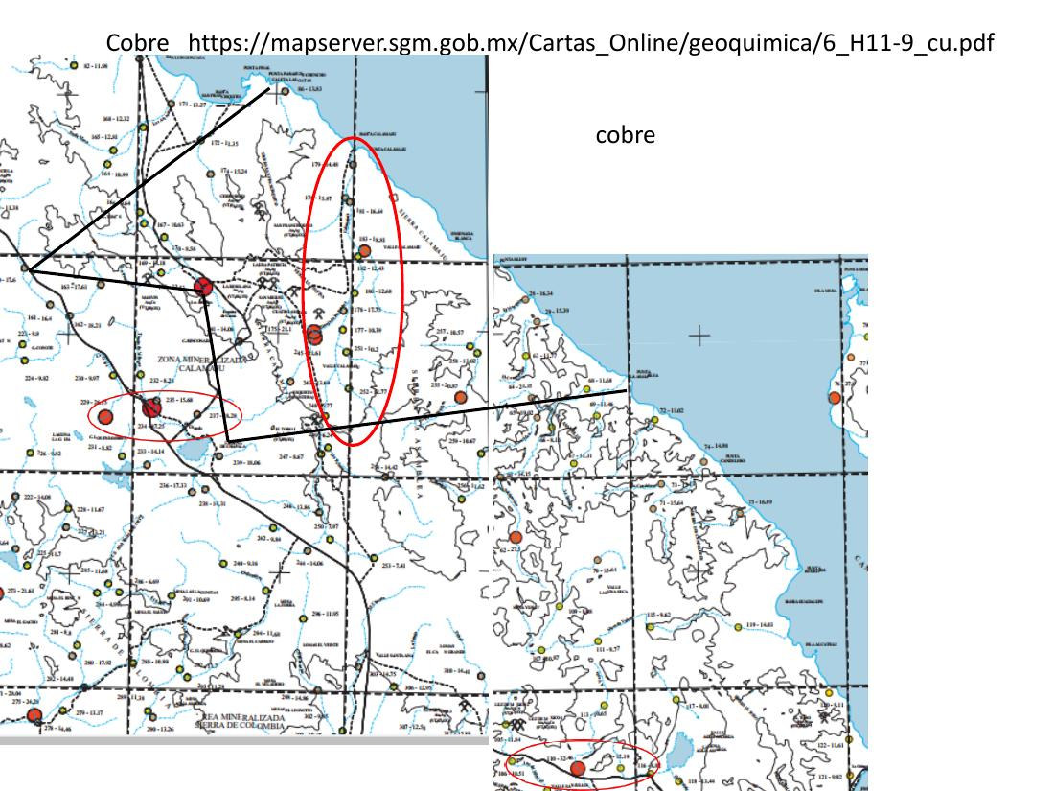
Regional mineral-map material supplied in the data room.
Location / regional project visual supplied in the data room.
Concession / mining-lot visual supplied in the data room.

